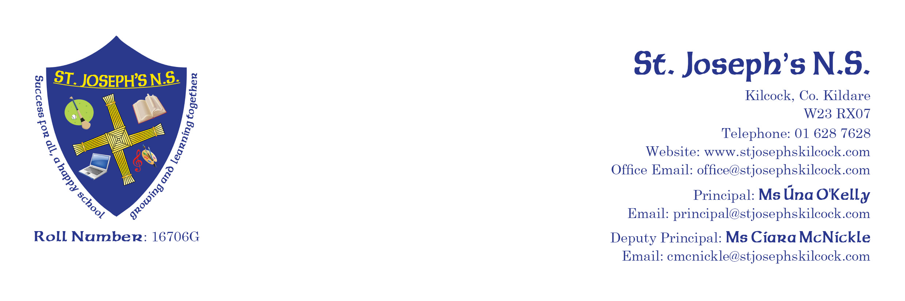
ST. JOSEPH’S N.S. APPLICATION FOR ADMISSION FORM
FOR ASD CLASSES 2026 2027

Child’s First Name: |  | Surname:
Home Address:  (including Eircode) |  | Alternate Address:  (including Eircode)
Date of Birth: |  | Parent/Guardian 1:
PPS Number: |  | Telephone Number:
Gender: | Male  Female | Email address:
 |  | Parent/Guardian 2:
Nationality: |  | Telephone Number:
Language spoken at home: |  | Email address:
If your child is a non-irish National please state how many years he/she has been resident in Ireland |  | Parents’/Guardians  Nationality:
Siblings attending St. Joseph’s N.S.: | Name: Class:  _________ _______  _________ _______  _________ _______

If there are any orders or other arrangements in place governing access to, or custody of the child, please provide details and include supporting evidence.

Last school attended:  Pre school attended: |  | Class in which you wish to place your child:

MEDICAL DETAILS

Please give details of any medical conditions your child may have including allergies:

Doctor’s Name and Phone Number:

In case of emergency I give permission for my child to be taken to hospital or the school doctor by ambulance/car. Circle response
Yes No
While we make every effort to ensure the safety of your child, we may need to contact you in the event of an accident or unexpected closing.

Please fill in alternative contacts should you not be available at that time:

Alternative Contact Name :
Relationship to child:
Telephone Number:

Alternative Contact Name :
Relationship to child:
Telephone Number:

Has your child any Special Needs/Disabilty/Disorder/Syndrome for which additional support in school may be required/recommended?

If yes, I attach details & Reports: Yes No Not Applicable
Does your child have any hearing/sight difficulties?

If yes, please give details: Yes No

Should your child or young person be placed on a waiting list for a place, their personal data may be shared with the National Council for Special Education for the purposes of planning for the provision of special education placements.

OTHER DETAILS
As part of school life the Health Board, Dental Services and the Parents Council may need your contact details (email address and/or phone number). I give permission to the school to give my details to the above authorities. Circle response Yes No
I wish my child to take part in the Catholic Religious Education Programme (Grow in Love) taught in his/her school. Circle response Yes No
If no, please speak to your child’s teacher in relation to alternative arrangements for him/her.
I have read the Code of Behaviour in the School Prospectus and agree to make all efforts to encourage my child’s compliance with St. Joseph’s Code of Behaviour. Circle response

Yes No

I support the wearing of the School Uniform as outlined in School Policy in the School Prospectus Circle response

Yes No

I support ALL school policies as outlined in the School Prospectus/website, including the Admissions, Code of Behaviour, Bí Cineálta, Healthy Eating, Substance Use Policy, Acceptable Use Policy etc. Circle response Yes No

I give permission for my child’s photo to be used on the school website and school social media account. Circle response

Yes No

I agree to the details on this Form being stored on the School Computer system as part of school records. Circle response

Yes No

Information for Department of Education and Skills Primary Online Database
The Department of Education and Skills have developed an electronic database of primary school pupils called the Primary Online Database (POD). This database will allow the Department to evaluate progress and outcomes of pupils at primary level,to validate school enrolment returns for grant payment and teacher allocation purposes. Religious, ethnic and cultural backgrounds are considered sensitive personal data categories under Data Protection legislation. Therefore, it is necessary for each pupil’s parent/guardian to identify their child’s religion and ethnic background, and to consent for this information to be transferred to the Department of Education and Skills. All other information held on POD is deemed by the Data Protection Commissioner as non-sensitive personal data.

In order to assist with the gathering of data please complete the following:

Child’s Name:

Birth Cert name if different:

Nationality of child:

Mother’s Maiden Name:

Is one of your child’s mother tongues (i.e. language spoken at home) Irish or English?  Yes  No | To which ethnic or cultural background group does your child belong (please tick one)  White Irish  Irish Traveller  Roma  Any other White Background  Black African  Any other Black Background  Chinese  Any other Asian Background  Other (inc. mixed Background)  No consent to share this
I consent for this information to be stored on the Primary Online Database (POD) and transferred to the Department of Education and Skills and any other primary schools my child may transfer to during the course of their time in primary school.
Yes No
An application will NOT be considered valid until this form is complete and we are in receipt of the following:
- Original Birth Certificate (will be copied & returned)
- Proof of Address
- Latest Reports and School Report (unless application is for Junior Infants)
- PPS Number
- Signature of Parent/Guardian

Parent’s signature: | Date:
If ANY of the above details change, please notify the school immediately

OFFICE USE ONLY

For which class: Year:
Date Application received: ________________ Waiting List Place Number: _______________
1. Birth Cert: Yes No
2. PPS: Yes No N/A 3. School report: Yes No N/A
4. Signature: Yes No N/A

